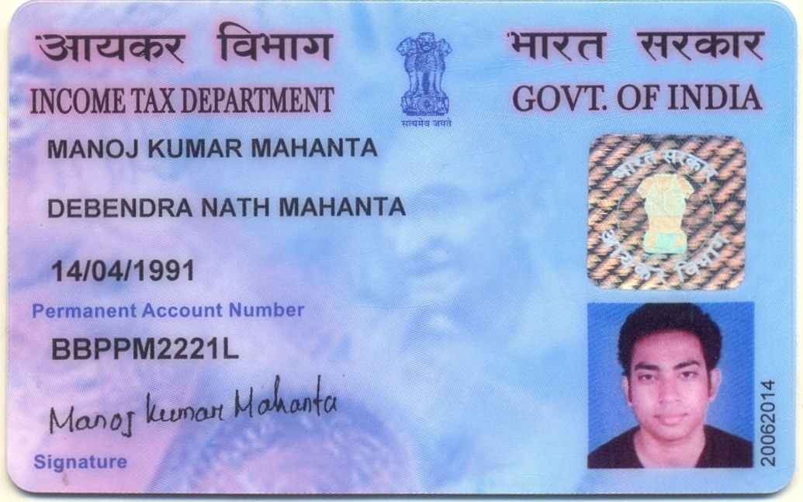

Candidate's Full Legal Name (as it appears on PAN)Vishal Nikam | Manoj Kumar Mahanta
Supplier Name (Registered Name) | People-prime Worlwide
Worked for CG previously? (IF yes share CG  Employee ID/GGID required | No
JOB Posting ID | CGEMJP00347353
Contact No (10 Digit No) | 9437841221
Email ID | manojmahanta.bangalore@gmail.com
Job Location (Work Location) | Bangalore
Notice Period (Immediate/ Notice to Serve) | Immediate Joiner
Highest Education (Regular or Distance) | B. Tech
Employment Detail – Last 2 yrs Working period  (Payroll Company) | Wipro Limited
College & University Full Name -Biju Pat t naik University T echnology | Biju Pattnaik University T echnology
Mandatory Skills & Experience  (quick checklist – verify each skill, years of  experience) | RPA -9.6 years
“Secondary” Skills & Experience | Project management- 2 years
Key Remarks (Supplier Comment) | Candidate Good at Communication Skill. He has relevant experience of 9.6 years.


MANOJ KUMAR MAHANTA
SENIOR AUTOMATION SOFTWARE DEVELOPER AND PYTHON EXPERT

Email :manojmahanta.bangalore@gmail.com Mobile/Whatsapp : +91 9861855058
Location : Bangalore Linked In: www.linkedin.com/in/manoj-mahanta-rpa

SUMMARY
Excellent RPA (Robotics Process Automation - Automation Anywhere),Ui-Path, C# & SQL Server skills with outstanding hands on Python experience. Aspiring to obtain a challenging position that will utilize my technical skills, Outstanding Project Management, Process and Solution Design skills for Career advancement as a Technical Lead in Intelligent Automation. Currently working on Gen AI & agentic AI.

EXPERIENCE

WIPRO LIMITED(TEAM Lead) Sept2024- Continue
- Team Lead RPA on A360 for managing a team of 6 RPA Developers to achieve 100% Deadline for 3 large Business Projects for 12 FTE (Full Time Employee) saves .Development completed for multiple Clients.
- Excellent Interpersonal Skills for Automation Requirements Gathering from Subject Matter Experts of Key Clients for creating Process and Solution Design Document for Review and Approval..
- Fulfilling Change Requests on existing Code and Identifying Bugs and Errors proactively through a Severity allocation as per client needs.
- Conducting Knowledge Transfer Sessions and Facilitating Knowledge Sharing Sessions amongst all Developers and Team Leads with Excellent Feedback.

R1 RCM Global Pvt Ltd (Senior Software Engineer) Feb2023-Nov2023
- Lead RPA Developer on A360 for managing a team of 6 RPA Developers to achieve 100% Deadline for 3 large Business Projects for 20 FTE (Full Time Employee) saves.
- Excellent Interpersonal Skills for Automation Requirements Gathering from Subject Matter Experts of Key Clients for creating Process and Solution Design Document for Review and Approval.
- Fulfilling Change Requests on existing Code and Identifying Bugs and Errors proactively through a Severity allocation as per client needs.
- Conducting Knowledge Transfer Sessions and Facilitating Knowledge Sharing Sessions amongst allDevelopers and Team Leads with Excellent Feedback.

RPA Infotech Pvt Ltd – Senior Software Developer Oct2021-Dec2022
- Successful migration of Desktop Automation V11 to A360 Bot and subsequent identification and fixingof Bugs and Environment Changes through Testing followed by Deployment in the New Production environment for 10 Client Projects over 6 months with excellent Client Feedback.

Virtusa Consulting Services Pvt Ltd – Senior Software Developer Jan2021-Nov2021
- Successful 100% Resolution of assigned tickets of AA (Automation Anywhere) and UIpath through an Agile methodology within stringent timelines.

Accenture – Application Development Analyst Nov2016-Sep2020
- Successfully submitted a Proof Of Concept for 2 Global Clients on Automation anywhere, Uipath & Blue prism tool that fetched me the highest Performance Bonus paid to any developer at my level in the India center.
- Promoted to a bigger responsibility of driving a critical project at the Global Client Off-shore site for successful implementation of Ross project despite previous deadline misses by the original Project Team for 10 FTE saves.

ILabs Enterprises (previously Avvas Infotech) – SoftwareDeveloper Mar2016-Nov2016
- Delivered 4 projects within stringent deadlines of Automation Anywhere on SAP, Citrix, Web Based Applications for Genpact’s Global Clients for a net saving of 15 FTE’s.

CERTIFICATIONS
A360, AA v10 Advance & Master , AA v11 Advance & Master, UI path Foundation

SKILLS
Automation Anywhere, A360, Ui-path, Python,C#,VB Scripting, Power BI, Machine Learning, SAP Automation, Power Automate, Project management, Stakeholder management, Excellent Communication Skills, Agile, Team Leadership Skills & Analytical Skills, IQ Bot, SAP Automation

EDUCATION

Bachelors in Technology – Computer Science Engineering Aug2009-Jun2013
Biju Pattnaik University Technology

PROJECTS

WIPRO– Team lead SEPT 2023 - Continue

DBCALC
Worked on Multiple USA Pension Scheme Clients. Developed Customer Interaction Bot with the End to End process design and document on A360 21.320 Version. Extensive Interaction with Clients for Project requirement business flow for SME and BA to Create TDD & PDD for the Development process. Following Automation Anywhere Coding Standard as per client template for new and change requests of each project. Thorough System Integrated Testing for all the test cases of the web based health insurance Portal. Total saves of 10 FTE.

R1 RCM – Senior Software Engineer Mar 2023 - Sep 2023

Claim Status
Worked on Multiple USA Health Care Insurance Clients. Developed Customer Interaction Bot with the End to End process design and document on A360 21.200 Version. Extensive Interaction with Clients for Project requirement business flow for SME and BA to Create TDD & PDD for the Development process. Following Automation Anywhere Coding Standard as per client template for new and change requests of each project. Thorough System Integrated Testing for all the test cases of the web based health insurance Portal. Total saves of 10 FTE.

RPA infotech Pvt Ltd-Senior Software Developer Feb 2022 - Nov 2022

Title Management Remarketing Surplus
Worked on Automation Anywhere Development on A360 21.200 for Transport Domain by Developing an interactive and intelligent Bot with an exhaustive End to End process documentation, development and testing for a mainframe application. Thorough System Integrated Testing for all the test cases of the web based transportation portal. Utilizing 2 ERP’s - Title Quest (Desktop application) & xcelerate Web application. Bot Updating output file in Excel and sending an automated email to Respective recipients for the update which resulted in Savings of 2 FTE’s Work.

RPA infotech Pvt. Ltd. -Senior Software Developer Nov 2021 - Mar 2022
Vendor request for Payment info
Worked on end-to-end development - Unit testing, Fixing SIT testing issue and given KT to Support people. For this process Used the main frame terminal Emulator. This a bit lengthy and logical Bot. Bot was designed to take Input data in Excel according to 6 Conditions from mainframe and it Saved 8 FTE for this project.

Accenture – Application Development Analyst Apr2020-Sep2020

FSFactory
In this project Worked on US Bank Loan Approval Process using python and AAv11.3. Worked on Python logic and Implemented on AA Python Script. We used Documentation Automation for User to Read the data from PDF or Word files from Customer hand Written Document. There was no Human Intervention after Reading of document & IQ bot Implementation.

Accenture –Application Development analyst May2018-Jul2019
Unity Media
Unity Media is a part of the Telecom Sector of Germany. We automated their process using AA10.6. with SVN & using Credential volt. I worked on RNS in VM work environment with several sub-processes of this project for completing the Development that gave 13 FTE saves that ultimately ensured smooth running of Projects.

Accenture –Application Developer Analyst May2019–Sept 2019
ROSS
ROSS is a transport web application in USA. We automated their process using AA11.3 with SVN. I worked on RNS in VM work environment with several sub-processes of this project for completing the Development that gave 5 FTE saves. I led the client Interactions for Business Requirement Gathering & creating Business process flows for Data base design.

